21.05 residential
25/01/2012 C86

    - Overview
25/01/2012 C86

This section applies to all land zoned Residential 1, Residential 3, Mixed Use and Activity Centre Zone located west of the Mullum Mullum Creek and the township of Warrandyte and parts of Wonga Park. These areas are shown on Residential Framework Plan 1.
Housing
Managing change and growth in the residential areas of Manningham is a key issue facing Council. Infill residential development and redevelopment of key strategic sites that consolidates the role of established urban areas and reduces developmental pressure in the areas with environmental values will be encouraged.
Whilst couples with children are the predominant household structure in Manningham, the key emerging trend is the smaller household type. The continuing ability of our residential areas to accommodate the changing lifestyles and housing needs of current and future populations is becoming an increasingly important issue. Whilst single detached dwellings will continue to represent the largest proportion of Manningham’s housing stock, there will be a need for a greater mix of housing in the form of medium and higher density residential developments. Higher density housing will be encouraged in close proximity to activity centres and along major roads and transport routes.
The Manningham Residential Strategy (2002) and the Manningham Residential Character Guidelines (2005) are key policy documents that seek to direct and manage the level of change in a manner that will best serve the interests of the municipality in terms of housing needs, built form and environmental outcomes. These documents encourage a range of housing types that meet the changing needs of the community and promote high design standards.
Key Redevelopment sites offer urban consolidation opportunities in well serviced areas and localities. The Eastern Golf course site is an identified Key Redevelopment Site in Manningham.
Subdivision
Effective subdivision design should respond to site opportunities and constraints. There are limited opportunities for large scale subdivision in Manningham. A key issue for Council is inappropriate infill subdivision of smaller lots.
Built form and neighbourhood character
Residential developments must be well designed, site responsive and not adversely impact on neighbours, the surrounding environment, streetscape and existing or preferred neighbourhood character.
It is intended to retain the existing bushland character of the Warrandyte township and Wonga Park area.
The key strategic directions for future residential development are illustrated in Map 1 - Residential Character Precincts, in this Clause.
Four precincts have been identified:
Precinct 1: Residential Areas Removed from Activity Centres and Main Roads
Precinct 2: Residential Areas Surrounding Activity Centres and along Main Roads
Precinct 3: Residential areas with Predominant Landscape Features
Precinct 4: Post 1975 Residential Areas.
The precincts seek to channel increased housing densities around activity centres and main roads where facilities and services are available. In areas which are removed from these facilities a lower intensity of development is encouraged. A low residential density is also encouraged in areas that have identified environmental or landscape features.
Precinct 1 – Residential Areas Removed from Activity Centres and Main Roads
This precinct applies to the areas that are removed from activity centres (shopping centres) and main roads.
An incremental level of change is anticipated in Precinct 1. The future development vision is to encourage development that reinforces existing front and rear setbacks and site coverage to provide opportunities for landscaping and retain areas of open space. Accordingly, this precinct will encourage a less intense urban form.
Whilst the design of future dwellings may vary from the existing built form, dwellings in this area will need to provide increased open space for the planting or retention of trees and associated landscaping. The prevailing character of low front fences, retaining walls or the absence of front fences will also be encouraged.
Precinct 2 – Residential Areas Surrounding Activity Centres and along Main Roads
This precinct applies to the areas surrounding activity centres and the areas along Main Roads.
The activity centres included in this precinct are: Bulleen Plaza, Tunstall Square, Macedon Square, Jackson Court, Donburn, Devon Plaza, Templestowe Village, The Pines and Doncaster Hill.
These areas are within close proximity to activity centres (local shopping centres) and community facilities. The Doncaster Hill Activity Centre is regarded as the prime location for redevelopment for residential, commercial and community uses and is identified as the only Principal Activity Centre in the municipality.
The main roads identified in this precinct are Doncaster, Tram and Elgar Roads, Manningham and part of Thompsons, Blackburn and Mitcham Roads. These areas are developed with a range of commercial and residential uses.
Whilst landscaping exists along the main roads, there are opportunities to introduce better landscaping standards to improve the appearance of the main roads in the municipality.
A substantial level of change is anticipated in Precinct 2. This area will be a focus for higher density developments. Three storey buildings, including ‘apartment-style’ developments, will be encouraged on larger lots.
Future development in this precinct is encouraged to:
- Provide for contemporary architecture
- Achieve high design standards
- Provide visual interest and make a positive contribution to the streetscape
- Provide a graduated building line from side and rear boundaries
- Minimise adverse amenity impacts on adjoining properties
- Use varied and durable building materials
- Incorporate a landscape treatment that enhances the overall appearance of the development.
- Integrate car parking requirements into the design of buildings and landform.

Within this precinct, there are three sub-precincts:
Sub-precinct - Main Road is an area where three storey (11 metres) ‘apartment style’ developments are encouraged on consolidated lots with a minimum area of 1800m2. Higher developments on the perimeter of the Main Road sub-precinct should be designed so that the height and form are sufficiently stepped down, so that the scale and form complement the interface of sub-precinct B or other adjoining zone.

Sub-precinct A is an area where two storey units (9 metres) and three storey ‘apartment style’ development are encouraged. Three storey, contemporary developments may only occur on consolidated sites with a minimum area of 1800m2. The area of 1800m2 must all be in the same sub-precinct. In this precinct, if a lot has an area less than 1800m2, a multi-unit development proposal can still be considered, but development should be a maximum of two storeys and have a maximum site coverage of 60%.

Higher developments on the perimeter of sub-precinct A should be designed so that the height and form are sufficiently stepped down, so that the scale and form complement the interface of sub-precinct B.

Sub-precinct B is an area where single storey and two storey dwellings are encouraged. There is no minimum land area for such developments.
Precinct 3 – Residential areas with Predominant Landscape Features
This precinct includes two separate areas including Wembley Gardens in Donvale and a part of Templestowe. The built form and characteristics of these areas is varied. The common feature is the vegetation, particularly the presence of large trees. The presence of the native and exotic vegetation in Templestowe and in Wembley Gardens gives these areas a distinctive environmental feel. Templestowe is in close proximity to the Yarra River. Development is required to be designed and sited to protect existing visual corridors that exist along the Yarra River and nearby parkland. The absence of front fences creates a sense of openness and reinforces the environmental character of the area.
In this precinct only minimal change is anticipated. Due to the importance of retaining and enhancing the existing vegetation, this precinct will encourage a low residential density in order to retain the existing native and / or exotic vegetation.
Dwellings need to provide generous front, side and rear setbacks to ensure spacing between dwellings when viewed from the street and to provide opportunities to conserve and enhance the existing pattern of vegetation and the existing landscape qualities of the precinct.
Buildings are to be designed to have regard to the natural landscape and topographic features of the site. On sites with a slope, methods to minimise height of floor level above natural ground level would be encouraged. Building height, design and materials should be designed to enable the dwelling to integrate with the surrounding area.
The prevailing character of low front fences, retaining walls, or the absence of front fences is also promoted.
Precinct 4 – Post 1975 residential areas
This precinct includes areas that have been predominately developed since 1975 with a substantial amount of development occurring between late 1980s and the 1990s.
Although some of the housing built in the 1970s is single storey, housing built in the 1980s and 1990s is predominantly double storey and in some instances three storeys.
In this precinct there is minimal unit development.
An incremental level of change is anticipated in this precinct.
Environmental and landscape issues
A key challenge for Council is to achieve a balance between protecting environmental and landscape characteristics and accommodating changing housing needs. The provision of new housing is directed by strategies that protect and enhance landscape character, neighbourhood character and environmental values. Any proposals to subdivide or develop land will also need to have regard to constraints such as steep slopes and land prone to landslip, wildfire and flooding.
Economic development issues
Council encourages home-occupations as an important means of achieving economic development and providing opportunities that enable residents to work from home. Benefits to the business owner include reduced travel time and flexible hours, and support for micro start up businesses. The needs of these businesses should be addressed while ensuring that residential amenity is not adversely affected.
Non-residential uses and commercial developments which do not have a community service role are discouraged from locating in residential areas. Commercial development remote from activity centres is also discouraged in order to protect the amenity of residential areas, the viability of activity centres and to ensure the safe and efficient functioning of the road network.
21.05-2 Housing
25/01/2012 C86

Key issues
- Accommodating population growth as outlined in Melbourne 2030 Planning for Sustainable Growth (2002).
- Providing a diversity of appropriate housing to meet changing lifestyles and housing needs.
- Need for urban consolidation to address housing growth.
- Potential impact of new development on the surrounding area.
Objectives
- To accommodate Manningham’s projected population growth through urban consolidation, in infill developments and Key Redevelopment Sites.
- To ensure that housing choice, quality and diversity will be increased to better meet the needs of the local community and reflect demographic changes.
- To ensure that higher density housing is located close to activity centres and along main roads in accordance with relevant strategies.
- To ensure that areas removed from activity centres and main roads as well as areas with predominant landscape features are protected from higher density development.
- To promote affordable and accessible housing to enable residents with changing needs to stay within their local neighbourhood or the municipality.
- To encourage development of key Redevelopment Sites to support a diverse residential community that offers a range of dwelling densities and lifestyle opportunities.
- To encourage high quality and integrated environmentally sustainable development.
Strategies
Strategies to achieve these objectives include:
- Encourage the provision of housing stock which responds to the needs of the municipality’s population.
- Promote the consolidation of lots to provide for a diversity of housing types and design options.
- Encourage and guide higher density residential development close to activity centres and along main roads identified as Precinct 2 on the Residential Framework Plan 1 and Map 1 to this clause.
- Allow housing development that respects existing neighbourhood character and supports incremental level of change in areas removed from activity centres and main roads identified as Precinct 1 on the Residential Framework Plan 1 and Map 1 to this clause.
- Maintain a low housing density in areas with predominate landscape features identified as Precinct 3 on the Residential Framework Plan 1 and Map 1 to this clause.
- Support an incremental level of change that respects existing neighbourhood character in residential areas developed post 1975 identified as Precinct 4 on the Residential Framework Plan 1 and Map 1 to this clause.
- Encourage development to be designed to respond to the needs of people with limited mobility, which may for example, incorporate lifts into three storey developments.
- Investigate the most appropriate suite of planning controls to achieve the desired outcomes for Key Redevelopment Sites.
Implementation
These strategies will be implemented by:
Zones and overlays
- Applying the Residential 1 Zone.
- Applying a Design and Development Overlay.
- Applying the Design and Development Overlay 8 to residential areas close to activity centres and along main roads (identified as Precinct 2 on the Residential Framework Plan 1 and Map 1 to this clause) to identify the location and guide the design of higher density residential development.
- Applying the Residential 3 Zone to residential areas removed from activity centres and main roads (identified as Precinct 1 on the Residential Framework Plan 1 and Map 1 to this clause) to ensure new development respects neighbourhood character and provides for an incremental level of change.
- Applying the Significant Landscape Overlay and the Design and Development Overlay to residential areas with predominate landscape features (identified as Precinct 3 on the Residential Framework Plan 1 and Map 1 to this clause) to ensure that the density, design and siting of residential development is appropriate to its landscape and the low housing density character of the area.
- Applying the Residential 1 Zone to residential areas developed since 1975 (identified as Precinct 4 on the Residential Framework Plan 1 and Map 1 to this clause) to provide opportunity for new development that respects neighbourhood character and for an incremental level of change.
Policy and exercise of discretion
- Implementing the Manningham Residential Strategy (2002).
- Implementing the Doncaster Hill Strategy (2002).
- Using Local Policy to guide the location, design and management of accommodation premises (Accommodation premises policy, Clause 22.04).
- Using Local Policy to ensure that people with limited mobility have the same level of access to buildings, services and facilities as any other person (Access for disabled people policy, Clause 22.09).
- Using Clause 22.15, Dwellings in a Residential 3 Zone, to ensure new development in residential areas removed from activity centres and main roads (identified as Precinct 1 on the Residential Framework Plan 1 and Map 1 to this clause) respects neighbourhood character and provides for an incremental level of change.
- Encouraging the provision of ramps and wide entrances to optimise accessibility within and around the home.
- Encouraging higher density residential development in locations close to activity centres and public transport (identified on the Residential Framework Plan 1 and Map 1 to this Clause).
- Using Clause 22.17 Eastern Golf Course Key Redevelopment Site Policy, to provide the strategic policy framework to guide the future redevelopment of the Eastern Golf Course Site.
- Implementing the Manningham Biosites: Sites of Significance Review (2004).
- Implementing the City of Doncaster and Templestowe Heritage Study, (1991).
- Implementing the Manningham Heritage Garden & Significant Tree Study – Stage 2, (2006).
- Having regard to Meredith Gould Architects Pty Ltd (February 2011) Eastern Golf Course Conservation Analysis and Policy, Melbourne, Victoria.
Further strategic work
Other actions
- Identifying key development sites and encouraging residential development that responds to demographic trends and the surrounding pattern of development.
21.05-3 Subdivision
02/10/2008 C52

Key issues
- Site responsive subdivision.
- Inappropriate infill subdivision.
Objectives
- To encourage subdivision which responds positively to site features and constraints, integrates well with the neighbourhood, provides a functional environment and achieves energy efficient and environmentally sensitive layouts.
- To ensure the upgrading or provision of appropriate infrastructure and open space as part of subdivision proposals.
- To ensure that infill subdivision addresses future development impacts on adjoining properties and the neighbourhood.
- To ensure that subdivision adopts environmentally sustainable design principles.
Strategies
Strategies to achieve these objectives include:
- Encourage subdivision layouts that consider neighbouring uses and developments.
- Encourage subdivision layouts to provide for the safety and security of residents and property.
- Ensure that subdivision and associated works in wildfire areas are appropriately sited, designed and managed to address wildfire risk.
- Promote the consolidation of lots to increase design options.
- Encourage subdivisions to be designed to provide adequate vehicle, pedestrian and bicycle links.
- Require appropriate open space and infrastructure contributions.
- Require three-dimensional building envelopes for infill subdivision.
- Ensure subdivision design and layout considers lot orientation, size and location of building envelopes and water re-use to achieve sustainable design outcomes.
Implementation
These strategies will be implemented by:
Zones and overlays
- Applying a Development Plan Overlay.
- Applying a Design and Development Overlay.
- Applying the Wildfire Management Overlay.
Policy and exercise of discretion
- Using Local Policy to guide subdivision design that is responsive to the environmental and visual characteristics of the streetscape (Battle axe blocks policy, Clause 22.11).
- Using Local Policy to guide the protection of environmental and landscape values in identified Wildfire areas and identification and addressing of risks from wildfire (Environmental and landscape significance protection in identified wildfire areas policy, Clause 22.14)
Further strategic work
- Preparing a Local Planning Policy to guide subdivision within existing residential areas.
- Investigating the preparation of a development contributions plan for the municipality for areas outside the Doncaster Hill Activity Centre.
Other actions
21.05-4 Built form and neighbourhood character
02/10/2008 C52

Key issues
- Scale and form of residential development and its impact on neighbourhood character.
- Improving residential design standards.
Objectives
- To encourage residential development that enhances the existing or preferred neighbourhood character of the residential character precincts as shown on Map 1 to this Clause.
Strategies
Strategies to achieve these objectives include:
- Require residential development to be designed and landscaped to make a positive contribution to the streetscape and the character of the local area.
- Ensure that where development is constructed on steeply sloping sites that any development is encouraged to adopt suitable architectural techniques that minimise earthworks and building bulk.
- Ensure that development is designed to provide a high level of internal amenity for residents.
- Require residential development to include stepped heights, articulation and sufficient setbacks to avoid detrimental impacts to the area’s character and amenity.
Implementation
These strategies will be implemented by:
Zones and overlays
- Applying the Mixed Use Zone.
- Applying the Activity Centre Zone.
- Applying a Vegetation Protection Overlay, Significant Landscape Overlay, Environmental Significance Overlay and/or Heritage Overlay where appropriate.
- Applying the Residential 1 Zone to residential areas developed since 1975 to provide opportunity for new development that respects neighbourhood character and for an incremental level of change.
- Applying the Residential 3 Zone to areas removed from activity centres and main roads to ensure new development respects neighbourhood character and provides for an incremental level of change.
- Applying the Design and Development Overlay to ensure that the design and siting of residential development is appropriate.
Policy and exercise of discretion
- Implementing the Manningham Residential Character Guidelines (2005).
- Using Clause 22.01, Design and development policy, and Clause 22.15, Dwellings in a Residential 3 Zone, to ensure that development is responsive to the scale and preferred character of the local neighbourhood.
Further strategic work
- Preparing residential design guidelines for the Warrandyte township.
- Reviewing the location of, and the preferred use and built form of, identified gateway sites.
- Preparing a Local Planning Policy to guide the future use and development of identified gateway sites, if appropriate.
Other actions
- Taking into account the views of Council’s Sustainable Design Taskforce on major development applications.
- Requiring applicants for significant proposals to engage in a collaborative design process including pre-application meetings with relevant Council staff.
21.05-5 Environmental and landscape issues
02/10/2008 C52

Key issues
- Impact of land use and development on biodiversity.
- Protection and enhancement of environmental values and significant landscapes.
- Design and construction of development in areas with topographical constraints and areas of landscape character, visual and environmental significance.
Objectives
- To ensure that land is developed in a way that is compatible with, and protects and enhances the character of the area, its landscape qualities, pattern of vegetation and environmental values.
- To ensure that the environmental significance, visual and landscape character of environmental residential areas, including the Warrandyte township, parts of Templestowe, Wonga Park, the Hillcrest area and Donvale/Doncaster East are maintained and enhanced.
- To ensure that existing vegetation is retained where appropriate and that replacement planting complements the character of the area.
Strategies
Strategies to achieve these objectives include:
- Require a site analysis plan of the site and surrounds showing the existing topographic and visual features and how a proposal responds to environmental and landscape features for all relevant planning proposals.
- Retain the predominance of single dwellings on allotments and discourage other forms of inappropriate residential development in environmental residential areas.
- Ensure that development in areas with recognised environmental and landscape values are designed to minimise the impact on vegetation and protect landscape character and heritage values.
- Require that buildings and works minimise visual impact by locating away from ridgelines and exposed slopes, incorporating screening treatments and non-obtrusive materials and colours.
- Encourage development on sloping sites to adopt suitable design techniques that minimise earthworks and building bulk.
- Avoid development, including vegetation removal, on land with slopes of greater than 20%.
- Ensure that buildings are set back appropriate distances from property boundaries to provide for landscaping and the inclusion of canopy trees.
- Ensure that development does not protrude above the prevailing height of the tree canopy in environmental residential areas.
- Ensure that existing trees are retained where appropriate and that replacement trees complement the character of the area.
- Encourage the protection, planting and maintenance of indigenous vegetation consistent with Net Gain principles.
- Ensure that buildings and/or works in wildfire areas are appropriately sited, designed and managed to address wildfire risk.
- Encourage development that meets higher construction standards and/or utilises alternative treatments to address wildfire risk in preference to vegetation removal.
- Encourage the longevity of older exotic species with landscape character or heritage values.
- Discourage inappropriate development and landscaping on sites adjacent to State Parks and other conservation reserves.
Implementation
These strategies will be implemented by:
Zones and overlays
- Applying the Residential 1 Zone.
- Applying a Design and Development Overlay to the Warrandyte township, parts of Templestowe and parts of Donvale/Doncaster East.
- Applying an Environmental Significance Overlay and/or Significant Landscape Overlay.
- Applying a Vegetation Protection Overlay.
- Applying the Wildfire Management Overlay.
Policy and exercise of discretion
- Implementing the Manningham Residential Character Guidelines (2005).
- Implementing the Manningham Heritage Garden & Significant Tree Study – Stage 2 (April 2006) which identifies vegetation of significance to be protected and maintained.
- Using Local Policy to guide the protection of areas and sites of environmental significance (Indigenous flora and fauna policy, Clause 22.02).
- Using Local Policy to guide the protection of environmental and landscape values in identified Wildfire Areas (Environmental and landscape significance protection in identified wildfire areas policy, Clause 22.14).
Further strategic work
- Implementing the Manningham Biosites: Sites of (Biological) Significance Review (2004).
- Implementing the Roadside Environmental Management Strategy (2004).
- Review the Roadside Environmental Management Strategy (2004) with regard to the CFA Roadside Management Guidelines.
Other actions
- Investigating the potential for establishment and enhancement of flora and fauna habitat and linking corridors between sites of conservation significance.
- Continuing to control and remove introduced pest plants and pest animals on a priority basis, with emphasis on the provisions under the Catchment and Land Protection Act 1994 and direction from the Catchment Management Authority.
21.05-6 Economic development issues
02/10/2008 C52

Key issues
- Impact of discretionary uses on residential amenity.
- Impact of non-residential and commercial uses located outside of activity centres on the viability of activity centres
- Linear commercial development outside activity centres.
Objectives
- To encourage uses with a community service role to locate in close proximity to activity centres or other community based facilities.
- To ensure that business activities do not compromise the residential amenity and character of the neighbourhood.
- To ensure that the range of uses within mixed use developments are compatible.
- To locate commercial uses such as restaurants within activity centres.
- To discourage the rezoning of land for commercial uses outside activity centres.
Strategies
Strategies to achieve these objectives include:
- Ensure that the establishment of uses with a community service role do not compromise the amenity of the neighbourhood.
- Ensure that commercial uses are located within activity centres wherever possible.
- Ensure that in considering planning permit applications for home occupations, adequate provision is made for on-site car parking and loading areas and that these are adequately screened from the street and adjoining land.
- Limit the impact of advertising signs on visual amenity.
- Ensure that the range of uses within a mixed use development does not adversely impact on each of the respective uses.
Implementation
These strategies will be implemented by:
Policy and exercise of discretion
- Implementing the Home-Based Business Strategy (1996) that encourages the establishment of appropriate businesses that do not compromise residential amenity.
- Implementing the Manningham City Council 2003-2006 Economic Development Strategy (2003).
- Using Local Policy to ensure that non-residential and commercial uses do not affect the amenity of the area. (Design and development policy, Clause 22.01, Accommodation premises policy, Clause 22.04, Non-residential uses in residential areas policy, Clause 22.05 and Eating and entertainment policy, Clause 22.06).
- Using Local Policy to ensure that advertising signs do not impact on visual amenity (Outdoor advertising signs policy, Clause 22.07).
Zones and overlays
Further strategic work
Other actions
- Promoting and distributing Manningham’s Home-based Business Information Kit (2005).

21.05-7 Reference documents
25/01/2012 C86

- John Patrick Pty Ltd Landscape Architects (2006) Manningham Heritage Garden & Significant Tree Study – Stage 2, Manningham City Council, Doncaster.
- Manningham City Council (2002) Manningham Residential Strategy, Manningham City Council, Doncaster.
- Manningham City Council, MGS Architects (2005) Manningham Residential Character Guidelines, Manningham City Council, Doncaster.
- Manningham City Council (2004) Manningham Biosites: Sites of (Biological) Significance Review, Manningham City Council, Doncaster.
- Manningham City Council (2004) Roadside Environmental Management Strategy, Manningham City Council, Doncaster.
- Manningham City Council (2003) Manningham City Council 2003-2006 Economic Development Strategy, Manningham City Council, Doncaster.
- Manningham City Council (1996) Home-based Business Strategy, Manningham City Council, Doncaster.
- Manningham City Council (2005) Home-based Business Information Kit, Manningham City Council, Doncaster.
- Meredith Gould Architects Pty Ltd (February 2011) Eastern Golf Course Conservation Analysis and Policy, Melbourne, Victoria.

Map 1 (Part 1) – Residential Character Precincts
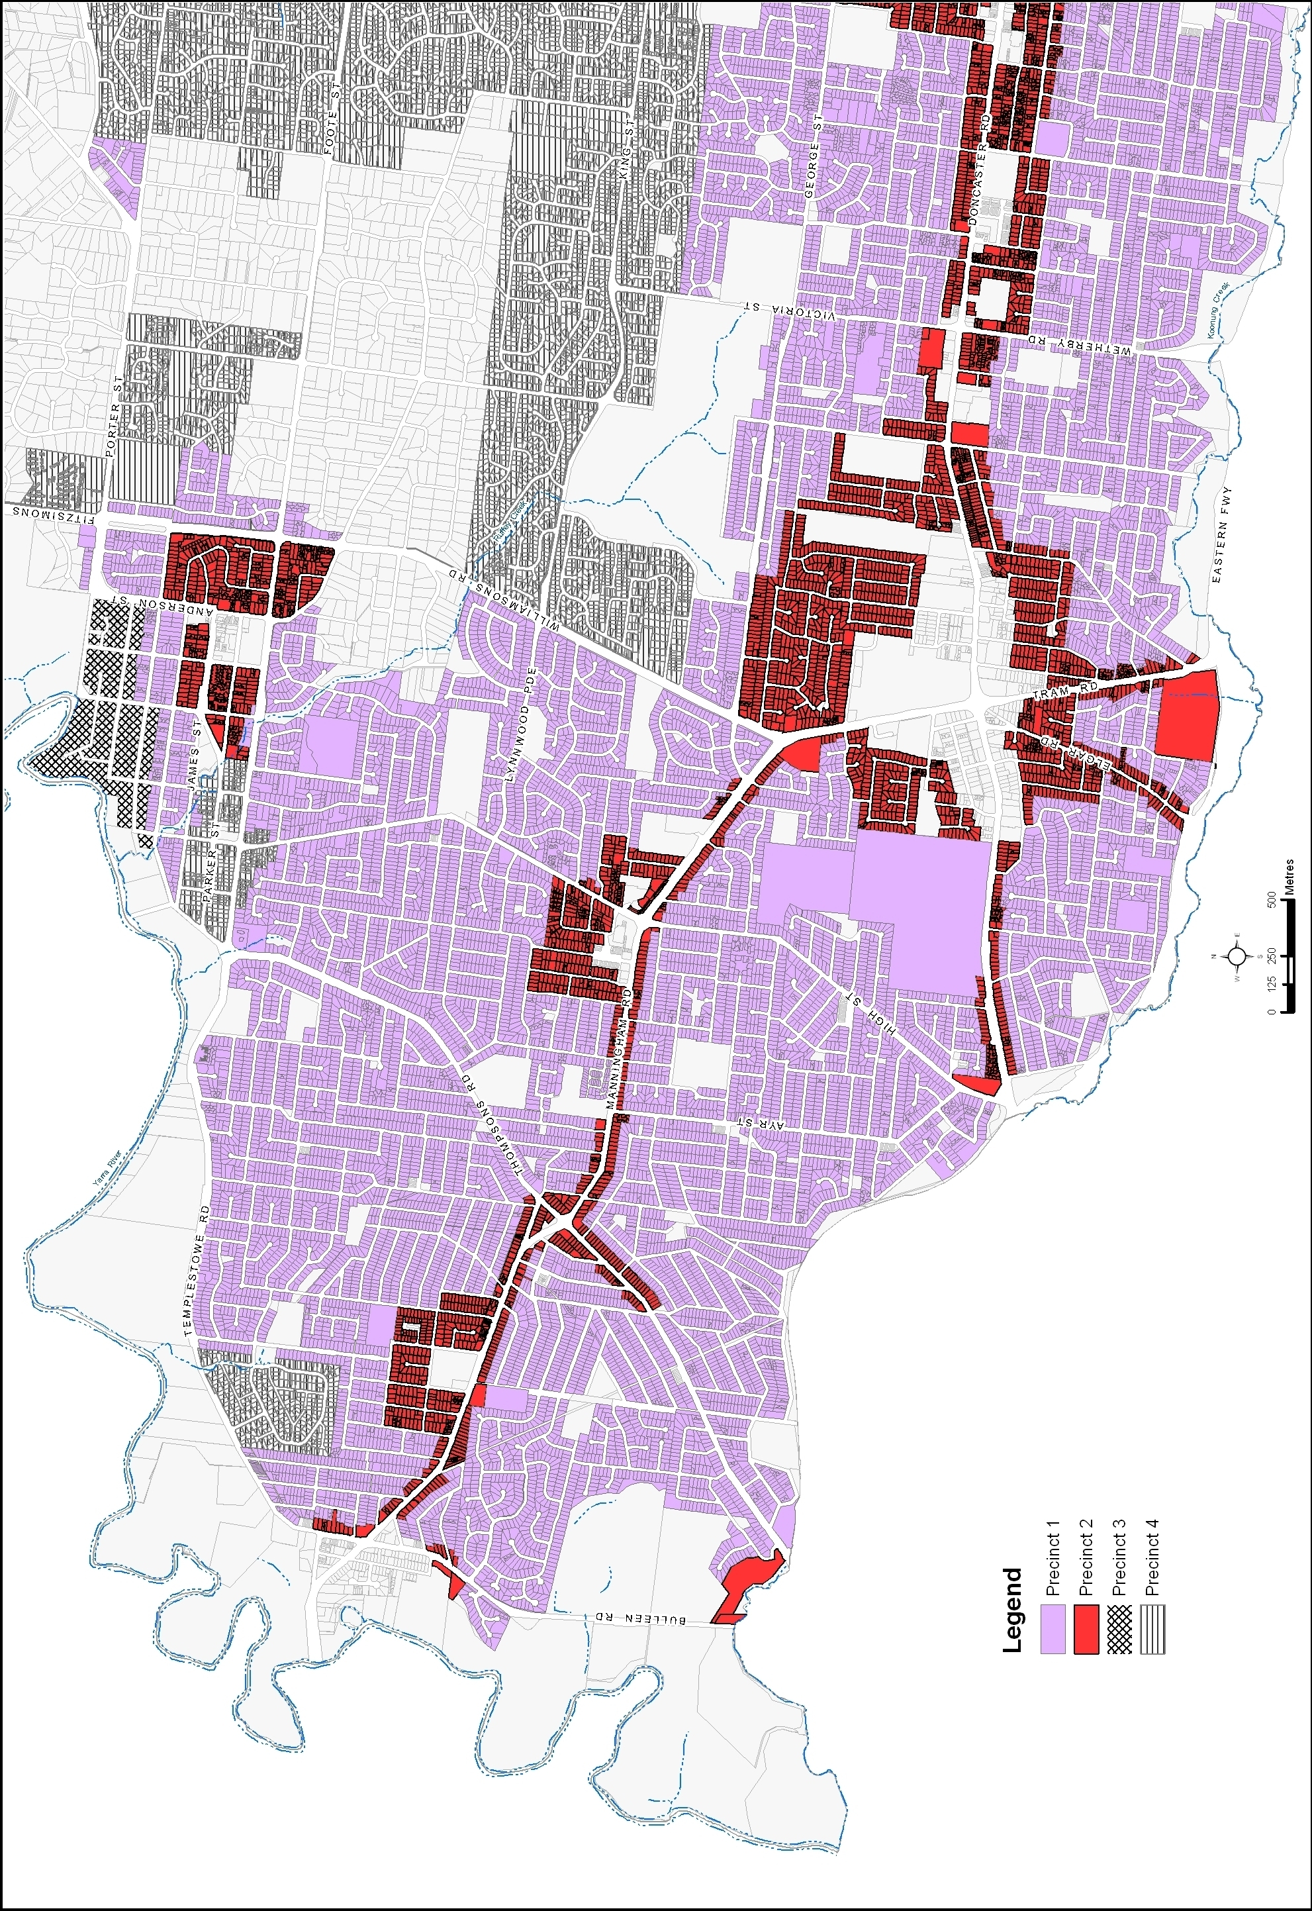

Map 1 (Part 2) – Residential Character Precincts
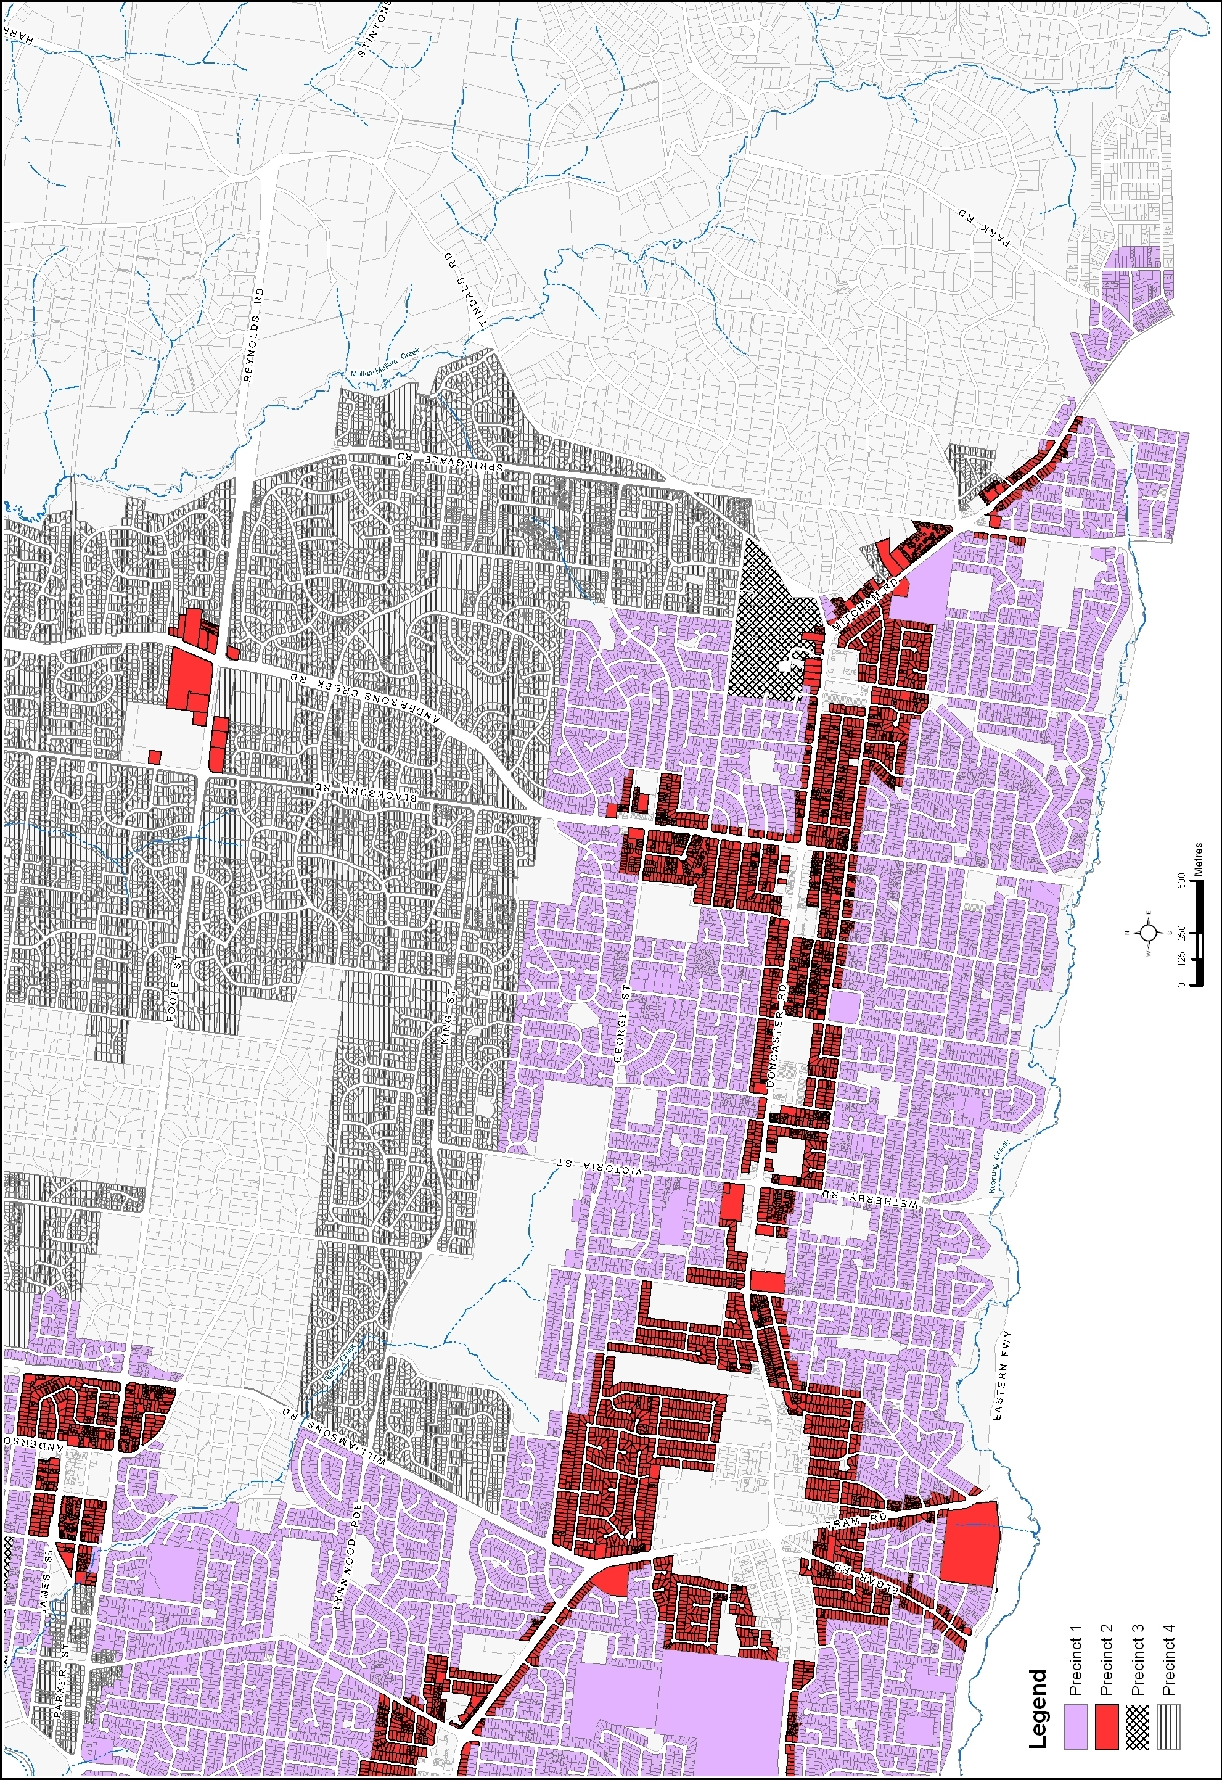

Residential Framework Plan 1


