Limiting global warming to 1.5 degrees C above pre-industrial levels was possible but would require “rapid, far reaching and unprecedented changes in all aspects of society”, the world’s main climate change body has said.
A special report released today by the Intergovernmental Panel on Climate Change (IPCC) said meeting the lower target would result in much better environmental and social outcomes.
But scientists have said the true extent of the efforts required were detailed in the 6000 papers analysed rather than the summary for policy makers thrashed out in South Korea over the past week.
CSIRO research scientist and executive director of the Global Carbon Project, Dr Pep Canadell, said the special report was probably the last reminder that there were no insolvable biophysical or technical impediments to meet the lowest temperature targets in the Paris Agreement.
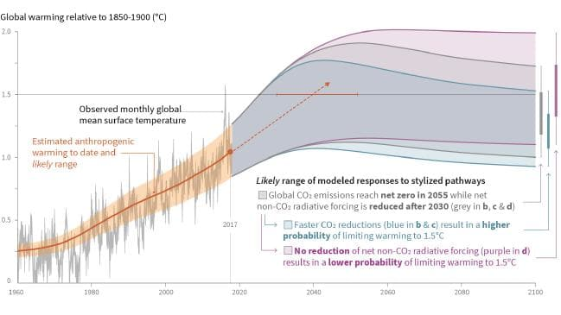Global warming relative to 1850-1900.
But he said it would require the “almost immediate establishment of a global carbon market, carbon pricing across all sectors of the economy, massive energy efficiency gains, significant consumer changes in diets, actions to reduce peak global population, and the immediate and growing deployment of options for the direct removal of CO2 from the atmosphere, including the pervasive need for carbon capture and storage in most cases.“
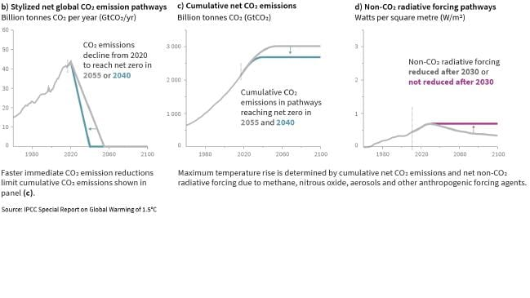CO2 emissions
To meet the target, the use of coal for electricity would be ruled out from 2050.
There would be drastic changes in land use, including reforestation and planting crops for energy to suck CO2 from the atmosphere and burying emissions when they were burnt.
A shift in diet towards less meat was described in the summary for policy makers as the need for “healthy consumption patterns”, “responsible consumption” and “sustainable diets”.
The provision of billions of dollars in finance to help developing nations would be crucial.
The IPCC said limiting global warming to 1.5C compared to 2C could “go hand-in-hand with ensuring a more sustainable and equitable society.”
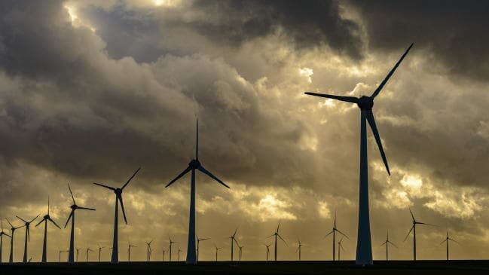To meet the target, the use of coal for electricity would be ruled out from 2050.
The latest report will be a key scientific input into the Katowice Climate Change Conference in Poland in December where governments are tasked with finalising the rule book to bring the Paris Agreement into effect.
“One of the key messages that comes out very strongly from this report is that we are already seeing the consequences of 1°C of global warming through more extreme weather, rising sea levels and diminishing Arctic sea ice, among other changes,” IPCC working group co-chair Panmao Zhai said.
The advantages of meeting a 1.5C target rather than 2C were detailed in the report.
Global sea level rise would be 10cm lower by 2100, the report said.
The likelihood of Arctic Ocean free of sea ice in summer would be once per century compared with at least once per decade.
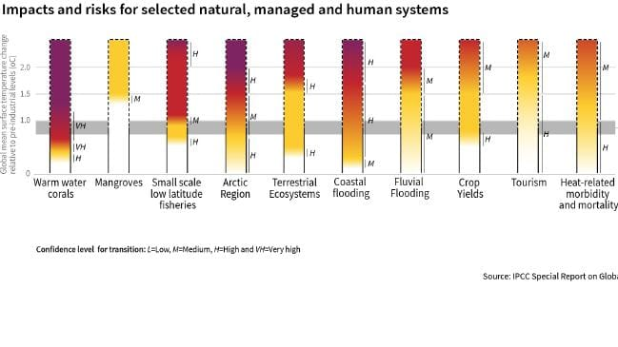Impacts and risks
Coral reefs would decline by 70 to 90 per cent with warming of 1.5C, whereas more than 99 per cent would be lost with 2C.
Another key IPCC official said while limiting warming to 1.5C is possible within the laws of chemistry and physics doing so would require unprecedented changes.
According to the summary for policy makers, human activities were estimated to have caused about 1.0C of global warming above pre industrial levels, with a likely range of 0.8 to 1.2C.
There is high confidence global warming is likely to reach 1.5C between 2030 and 2052 if it continues to increase at the current rate.
Trends in intensity and frequency of some climate and weather extremes had been detected over time spans during which about 0.5C of global warming occurred.
Warming from past emissions would continue but there was medium confidence these alone were unlikely to cause global warming of 1.5C.
There was high confidence that reaching and sustaining net-zero global human CO2 emissions would halt human caused global warming on multi-decadal timescales.
To meet a target of 1.5C warming, global net human C02 emissions would need to decline by about 45 per cent from 2010 levels by 2030, reaching net zero around 2050.
To reach a 2C target, emissions were projected to fall by about 20 per cent by 2030 and reach net zero around 2075.
For energy, to meet a 1.5C target, renewables were projected to supply 70 to 85 per cent of electricity in 2050.
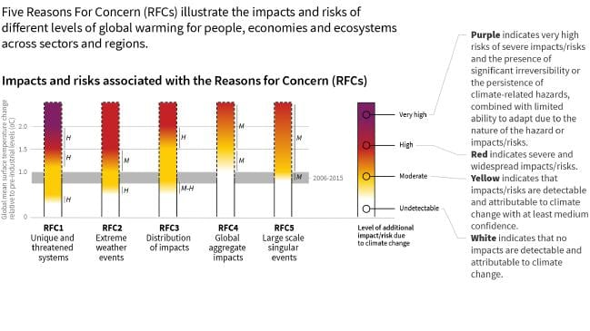Reasons for concern.
Nuclear and fossil fuels with carbon capture and storage were modelled to increase in most 1.5C pathways.
The use of CCS would allow the electricity generation share of gas to be approximately eight per cent of global electricity in 2050.
“The use of coal shows a steep reduction in all pathways and would be reduced to close to zero per cent of electricity (in 2050),” the report said.
All pathways that limit global warming to 1.5°C with limited or no overshoot project the use of carbon dioxide removal (CDR) on the order of 100—1000 GtCO2 over the 21st century.
Existing methods of carbon dioxide removal afforestation and reforestation, land restoration and soil carbon sequestration, bioenergy with carbon capture and storage (BECCS), direct air carbon capture and storage (DACCS).
Dr Canadell said negative emissions need to be used not as an excuse to defer action now, but as a need that has emerged largely from the slow climate change action over the past two decades.

GRAHAM LLOYD
ENVIRONMENT EDITOR
Graham Lloyd is a fearless reporter of all sides of the environment debate. A former night editor, chief editorial writer and deputy business editor with The Australian, Graham has held senior positions nationa... Read more

Share this article
- Facebook
- Twitter
- Email

